Overview:

* Very good on throw ins UCSD was 96.7% accurate and we limited Sac State to 75%
* Good passing accuracy 81.5%
* Didn’t let Sac State get a single shot with xG greater than .08
  + 9 Shots with only 1 on target | Total xG of .24
* Very good forward passing accuracy 75% best this season and exceeding goal by 3%
  + Jonah had an extremely high forward passing accuracy of 94%
  + Only 38% of Evan’s passes were forward compared to Keenai’s 65.5%
  + Very good passing accuracy in the middle of the pitch
* Very good crossing accuracy of 47%
* 226 Passes on the left flank and only 112 passes on the right flank
* Overall defensive duels accuracy was alright at 58%
  + Did a very good job winning duels around the box
  + Left side won 68.7% of duels while right side only won 44% of duels
  + James(40%) and Jonah (56%) were the ones getting beat on the right side most of the time
  + Carter (91.6%) and Keenai (80%) had very high win rates defensively
* Overall offensive duels accuracy was decent at 32.4%
  + James, Val, McGee, and Carter had a good offensive duels win rate
  + We didn’t get any threatening offensive duels on the right flank
  + Got more offensive duels in and around the box compared to fullerton

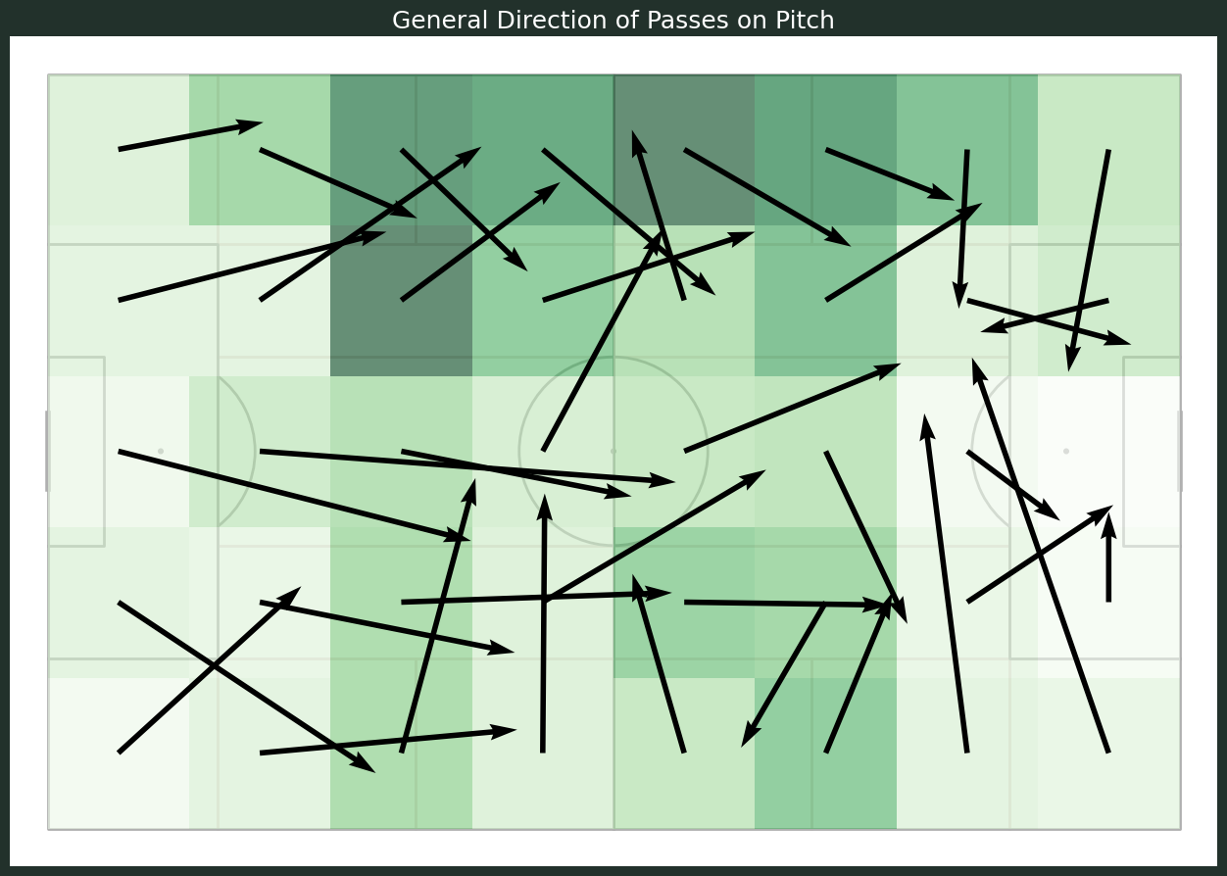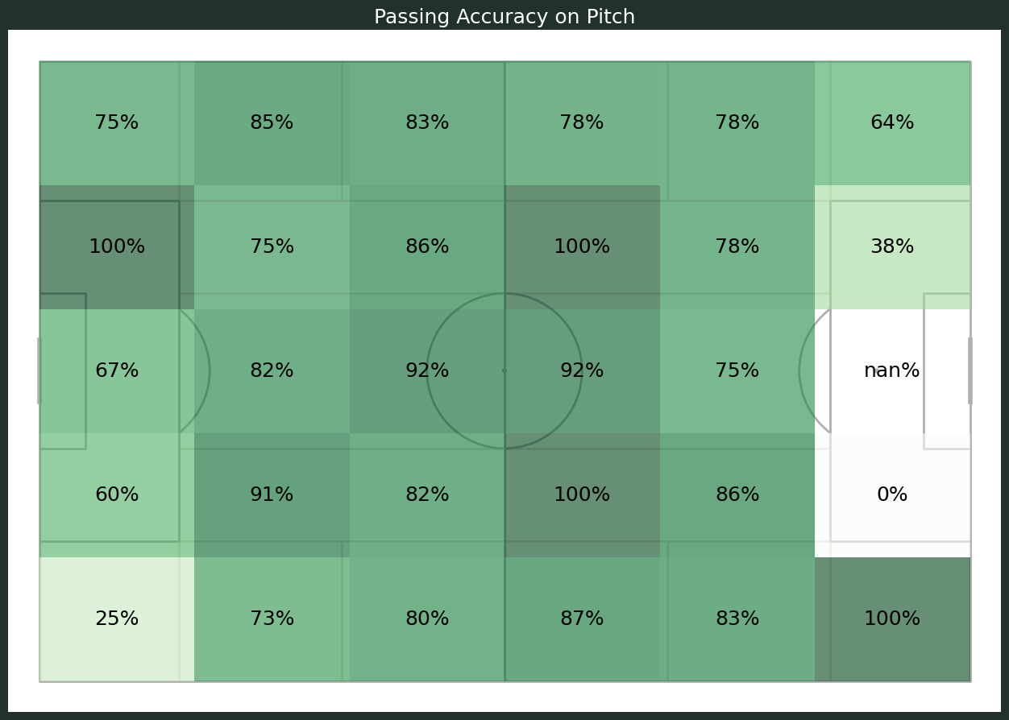

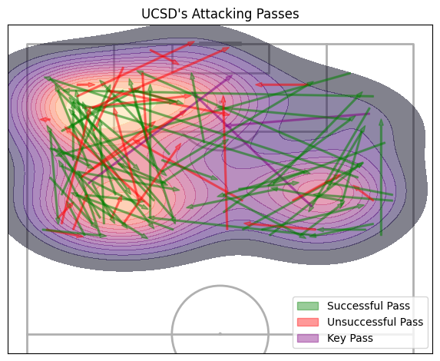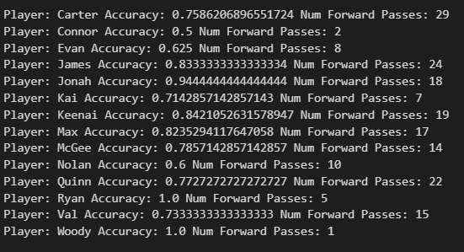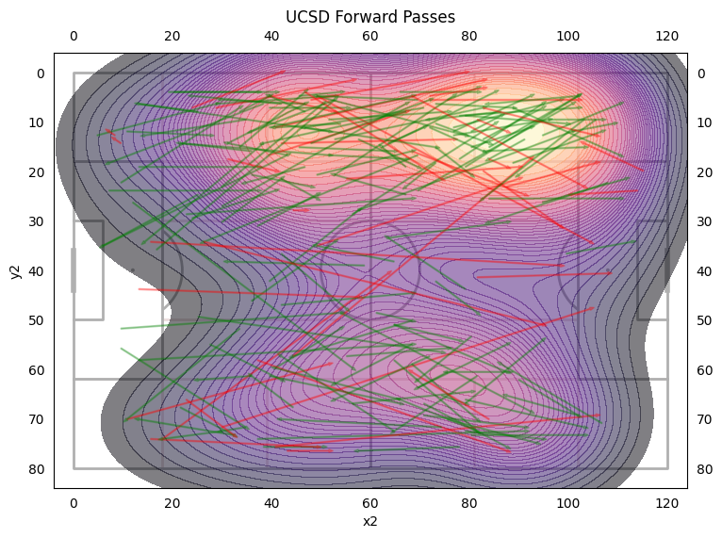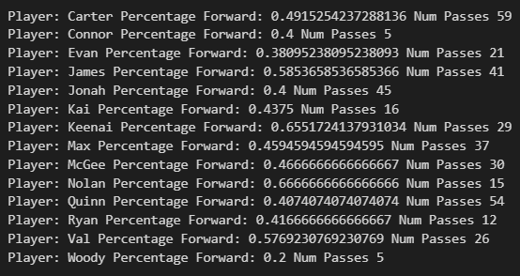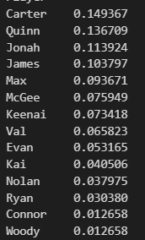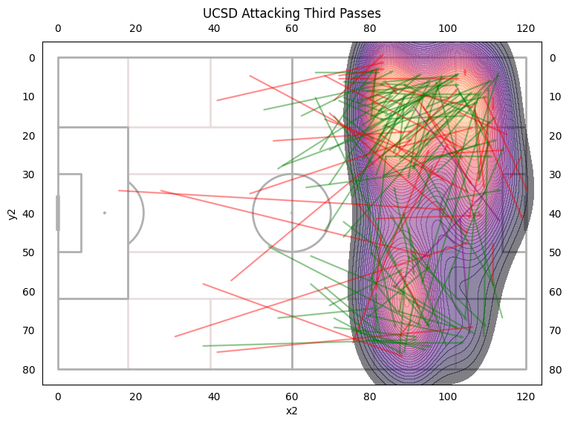

←Player passes percentage of team (i.e. Carter had 14.9% of UCSD’s passes)

